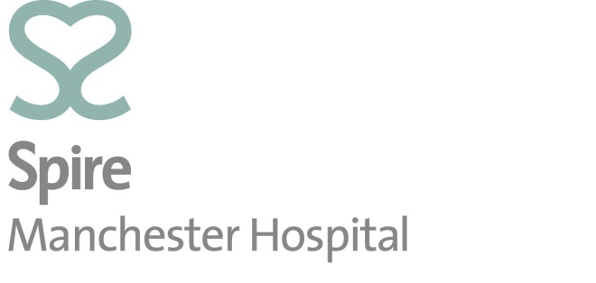

Eating Well After
Weight Loss Surgery
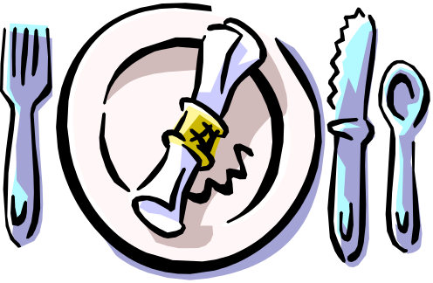

Modified consistency
Initially after surgery there is a need to restrict the consistency of food that you consume. This is due to the presence of swelling from your surgery. Following a sleeve or gastric bypass you will also have internal stitches that need time to heal. Having foods that are too solid too quickly can be exceptionally dangerous and must be avoided. As the weeks progress there is more room in your new stomach and you can gradually increase the consistency of food back to a normal consistency.
 | Week 1 | Week 2 | Week 3 | Week 4 | Week 5 | Week 6
Band | Liquid | Puree | Soft | Solid | Solid | Solid
Sleeve | Liquid | Liquid | Puree | Puree | Soft | Soft
Bypass | Liquid | Liquid | Puree | Puree | Soft | Soft

It can take several months to fully progress back onto a normal food consistency. Foods such as bread, chicken, tough meats, skins of fruit and vegetables can sometimes be difficult to tolerate longer term. Everyone is different. You are the best person to judge if you can tolerate a specific food. For example if you feel discomfort, experience nausea or vomiting or abdominal pain it’s your body telling you, that you are not ready for that food. Hold off for a few days and retry at a later date.
 | Description of Modified Consistency
Liquid | Should flow freely.  Should be able to move through a straw.
Puree | Should be a thick, smooth, uniform consistency.  A food that has been pureed and sieved to remove particles.  Can be eaten with a fork or spoon.  Will hold its own shape on a plate.  No chewing is required.
Soft | Food that is moist, with some variation in texture.  Has not been pureed or sieved.  Foods easily mashed and broken into pieces with a fork.  Meat requires very little chewing.
Normal | Any foods

Liquid Consistency
Liquid foods are easy for your stomach to digest and it gives the digestive system a chance to heal. The volume of food that you can consume is significantly reduced and you must therefore remember to take your time and sip fluids slowly. If you drink too fast there is an increased risk of nausea and vomiting. Initially you may be apprehensive, this is completely normal. As you become more accustomed to the volume of liquids that you can tolerate you will feel much better.
It is important to keep yourself well hydrated. One of the most common complaints in the first week after bariatric surgery is light headedness, headache and nausea. All of these symptoms can be related to dehydration. It is advisable to aim for at least 2500ml(8-10 cups) of fluid per day. A good sign is to check the colour of your urine.
A liquidiser is a brilliant way to ensure your food is the correct consistency. A thick soup (Homemade or bought) could be blended to a thin soup by adding some additional water. You could make a homemade smoothie and add additional milk to thin the texture. Buy a greek yoghurt and add your own fruit using a liquidiser to gain the right consistency
Some manufactured soups, yogurts and liquid slimming aids may appear to be healthy but can often contain high amounts of fat or sugar. Always check the nutritional label. Aim for <8g sugar / 100g and < 5g total fat / 100g. It is important to avoid foods that have a higher content than this to maximise your weight loss. Following a gastric bypass high concentrations of sugar and fat will increase the risk of diarrhoea, dumping syndrome and fatty stools.
Fresh fruit juice is often high in natural sugars and subsequently it is recommended to dilute 50: 50 with water to dilute the concentration. Whilst ice cream is liquid it is high calorie and should therefore be avoided.
Having spent the required time on liquids you can then progress onto puree foods. Your body will tell you if it is not ready for this consistency. If you begin to feel nauseous, vomit or have increased pain it suggests that you are not quite ready for that specific consistency. Try not to panic go back to the liquid consistency and retry in a few days.

Liquid Consistency | Portion size
Skimmed Milk | 200ml ( 1cup)
Semi skimmed milk | 200ml ( 1cup)
Low fat & low sugar yoghurt (no bits / no lumps)  Muller light, Activia fat free, alpro soya smooth | 1
Smooth thin soup (no bits / no lumps/ no cream)  Weight watchers, Baxters, Heinz vegetable, Be good to your self | 200ml (1 cup)
Sugar free squash( reduced sugar) | 200ml (1 cup)
Fromage frais / Mousse. | 1
Home made smoothie made with milk | 200ml (1cup)
Tea / Coffee (Weak ) | 200ml ( 1cup)
Sugar free jelly | 200ml (1cup)
Oxo / Bovril / Marmite | 200ml (1 cup)
Orange juice / apple juice (Dilute 50:50) | 200ml ( 1cup)
Home made soup | 200ml (1 cup)
Vegetable juice | 200 ml ( 1 cup)
Water | 200ml (1 cup)
Home made Latte | 200ml( 1cup)
Pro biotic drink | 125ml carton

Puree Consistency
Food should be of a baby food /apple sauce consistency. It should be smooth in texture and should not need chewing. At this stage your calorie intake will be less than 500kcal/day. You should aim for 5-6 small puree meals a day. Your portion size for each meal should be around 3 tablespoons.
Your new stomach is sitting higher up and therefore you may feel tightness in your chest when you eat. Don’t be surprised at how quickly you feel full, this is normal and to be expected.
There is not enough room in your new stomach to hold a small meal and a drink at the same time. To avoid feeling too full, avoid drinking fluid at the same time as you eat.
A liquidiser is still useful at this stage to ensure your food is the correct consistency. Extra liquids such as gravy and low fat sauces are a good means of thinning the texture of your food.
Some people buy baby food. These are designed to meet the nutritional needs of a baby and are subsequently of little nutritional value to an adult. Every day foods pureed to the correct consistency will be more advantageous.
Any food can be liquidised. You may wish to puree a meal. For instance shepherd’s pie, pureed fish and potato or spaghetti bolognaise. These foods liquidise rather well and are very nourishing.
Continue to check food labels ensuring <8g sugar / 100g and <5g total fat. This will help maximise your weight loss whilst avoiding any unnecessary side effects such as diarrhoea or dumping syndrome.
If you commence puree foods and experience any of the following symptoms (nausea or vomiting, abdominal discomfort), take a step back to a liquid consistency. Allow a couple of days for your stomach to settle and retry.
Once you are tolerating a pureed consistency you can then progress onto soft foods.

Puree Consistency (3 tbsp/meal)
25g puree fish (tuna, salmon, mackerel, pilchards, sardines) 2 tbsp puree potato.
3 tbsp puree fish pie
25g Puree meat (chicken, turkey, beef) with 2 tbsp puree potato.
3 tbsp puree shepherd’s pie.
3 tbsp puree potato with 25g soft cheese (laughing cow light, Philadelphia light.
3 tbsp puree corn beef hash.
2 tbsp of Puree vegetables (carrots, swede, turnip, parsnips) with 1tbsp puree potato and gravy.
1 tbsp puree spaghetti hoops with 2 tbsp potato
2 tbsp Puree fruit without skins (banana, apple, peaches, strawberries)
3 tbsp puree lasagne or spaghetti bolognaise.
3 tbsp puree tinned fruit in own juice
3 tbsp puree rice pudding
3 tbsp Yam / plantin or sweet potato
3 tbsp porridge
½ weetabix
4 tbsp ready brek
200ml Soup (Smooth soup but can be thicker than liquid stage)
3 tbsp Low sugar breakfast cereal with 100ml semi skimmed milk/skimmed milk
3 bsp low fat custard

 | Example Of Puree Meal Plan
Breakfast | 3 tbsp porridge
Mid Morning | Low fat low sugar yoghurt
Lunch | Puree tuna with 2 tbsp puree potato
Mid Afternoon | Glass of semi skimmed milk
Evening Meal | 3 tbsp corn beef hash
Super | Glass of semi skimmed milk

Soft Consistency
Once you feel comfortable with a puree consistency you should progress onto soft foods. Food should moist and tender with some variation in texture. By this stage a liquidiser should not be required. Your portion size should be around 4-5 tablespoons. Your calorie intake is likely to be in the region of 600-700kcals/day maximum. You should aim for 4-6 small meals/day.
Chewing your food well is essential. This will ensure that food does not get stuck. Take your time when eating and always remember to stop as soon as you start to feel full. Your stomach can only hold a small quantity of food if you eat more than this you will be sick.
It is not recommended that you drink at the same time as you eat. Drinking before your meal fills your stomach with liquid leaving little room for food. Drinking fluid after a meal speeds up the rate at which food leaves your stomach which can increase portion size and reduce the feeling of fullness. Aim to drink your fluids in between meals, either ½ hour before or ½ hour after you eat.
Prior to your surgery your stomach has a large holding capacity to hold fluid. After surgery this is not the case. Dehydration is one of the most common reasons for re admission to hospital. . It is recommended that you aim for at least 2500ml/day.
To maximise your weight loss food choices should be as healthy as possible. You should aim for <8g sugar / 100g and 5g total fat / 100g, when reading food labels. This will prevent stomach irritation and dumping syndrome (gastric bypass only).
If you commence soft foods and experience any of the following symptoms (nausea or vomiting, abdominal discomfort), take a step back to a puree consistency. Allow a couple of days for your stomach to settle and retry.
Soft Consistency (4-5 tbsp/meal)
4 tbsp fish pie
2 tbsp mashed potato, 1 tbsp of carrot and 1 tbsp turnip with gravy
2 tbsp Tender fish (tuna, salmon, mackerel, sardines) with 2 tbsp mashed potato
4 tbsp Shepherd’s pie / cottage pie
Jacket potato (no skin) with Philadelphia light
Jacket potato (no skin)with 2 tbsp cottage cheese
Jacket potato (no skin) with 2 tbsp tuna fish
4 tbsp cous-cous
4 tbsp casserole
Scrambled egg made with 1 egg
Rice pudding
Omelette made with 1 egg
Cooked boiled rice
3 tbsp cooked pasta with 25g mince meat and bolognaise sauce
1 piece of soft fruit without skin (banana, apple, pear).
Soft cereal ( 4tbsp)

 | Example Of Soft Meal Plan
Breakfast | 1 weetabix with semi skimmed milk
Mid Morning | Banana
Lunch | Omelette
Mid Afternoon | Low fat rice pudding
Evening Meal | 4 tbsp shepherd’s pie
Super | Glass of semi skimmed milk

Solid consistency
Surgery is a tool. You still need to make the right food choices to gain the most from your procedure. You should aim for regular meals, adequate protein, a small quantity of complex carbohydrates, low fat and low sugar food choices, fibre as tolerated and alcohol in moderation.
Lifestyle changes and exercise are also important and a combination of all three will give you the best results. Healthy eating is not just about a healthy body weight. It should also incorporate a variety of food and food groups. It should be flexible to fit in with your lifestyle. Any plan must be sustainable and maintainable for the rest of your life.
Once you can tolerate a solid food consistency you should aim for a variety of healthy food choices and food groups to help reduce the risk of nutritional deficiencies.
Don’t panic if you initially struggle to manage some foods this is normal and usually eases with time. Some days you can tolerate food well. Some days the same food can make you feel sick. To improve food toleration chew food well (chew at least 30 times) and take your time when eating. This is especially important when having meats, bread or high fibre foods such as fruit and vegetables. If you experience nausea, vomiting or discomfort, revert back to puree/soft foods to allow the stomach to settle and retry at a later date.
Initially after surgery liquid, puree and soft foods are good choices. Longer term aim for solid food. If food is too moist it will slip through your band, sleeve or new stomach pouch resulting in consumption of more food. A solid consistency will leave you feeling fuller for longer.
If you are stressed or anxious this can irritate the stomach meaning it can be more difficult to tolerate food. Smoking also increases the risk of stomach irritation which can further exacerbate poor food toleration.

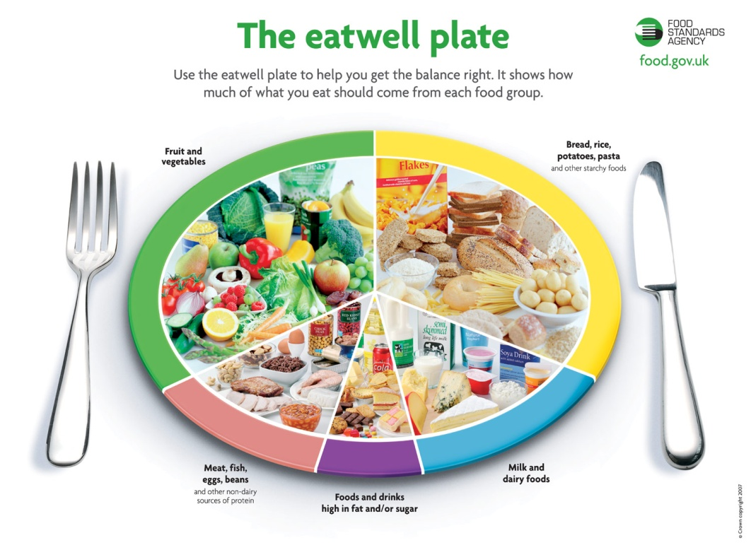

Regular Meals

The body needs fuel to function, without food it cannot work to its full potential. Regular meals provide a steady release of energy across the whole day. Following surgery you must eat regularly to ensure a steady source of fuel as unlike before surgery you cannot consume a large amount of fuel in one go.
Long periods without food can increase hunger, make you more tired & irritable and make you crave for sweet foods such as biscuits and chocolates. Ensuring regular meals including breakfast, lunch and evening meal will help to avoid this.
In the first few months the size of your meal should be around 5-6 tablespoons. It is recommended that you have your own small plate, bowl and cup to help you judge your portion size. Over time your portion size will slightly increase but is likely to be ¼ - ⅓ of your pre surgery intake. Protein foods should make up ¼ of your plate, carbohydrates ¼ of your plate and ½ of your plate should be made up of vegetables.

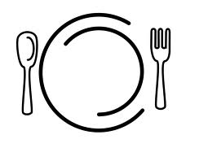Carbohydrates: bread, cereal, pasta, rice and potatoes
Protein
Carbs
Vegetables
Many individuals are scared to eat food that contains carbohydrate, as they believe these foods cause weight gain. This is not true. Complex carbohydrates are a good source of energy, fibre, vitamins and minerals. Choosing the right carbohydrates can provide a filling and satisfying basis for meals. It is often the things we add to carbohydrate that increases the calorie content.
Wholemeal breads, pasta and rice are an excellent source of fibre and are a useful means of preventing constipation. You should aim for wholemeal/high fibre varieties whenever possible.
You will note a significant reduction in the quantity of carbohydrates that you can consume. You should aim for 1 portion of carbohydrates at each meal. Soft and doughy bread, pasta and rice can be more difficult to tolerate. If toleration of bread remains difficult try a wholemeal or granary variety. Toast is also often easier to digest. Tortilla wraps and pita bread are good alternatives for sandwiches. Crisp breads and crackers are also useful sources of carbohydrates. If rice or pasta are difficult to tolerate always ensure a low fat sauce such as bolognaise which will help these foods to more through the stomach.
Carbohydrate | Portion guide
Muesli | 4 tbsp
Shredded wheat | 1
Porridge with semi skimmed milk | 27g sachet
Weetabix | 1
Rice Krispies | 5 tbsp
Cornflakes | 5 tbsp
Wholemeal Bread | 1 slice
Tortilla wrap | 1 small
Pitta bread | 1
Chapatti | 1 small
Bagel | ½
Rice, plain, boiled | 3 tablespoons
Pasta | 3 tablespoons
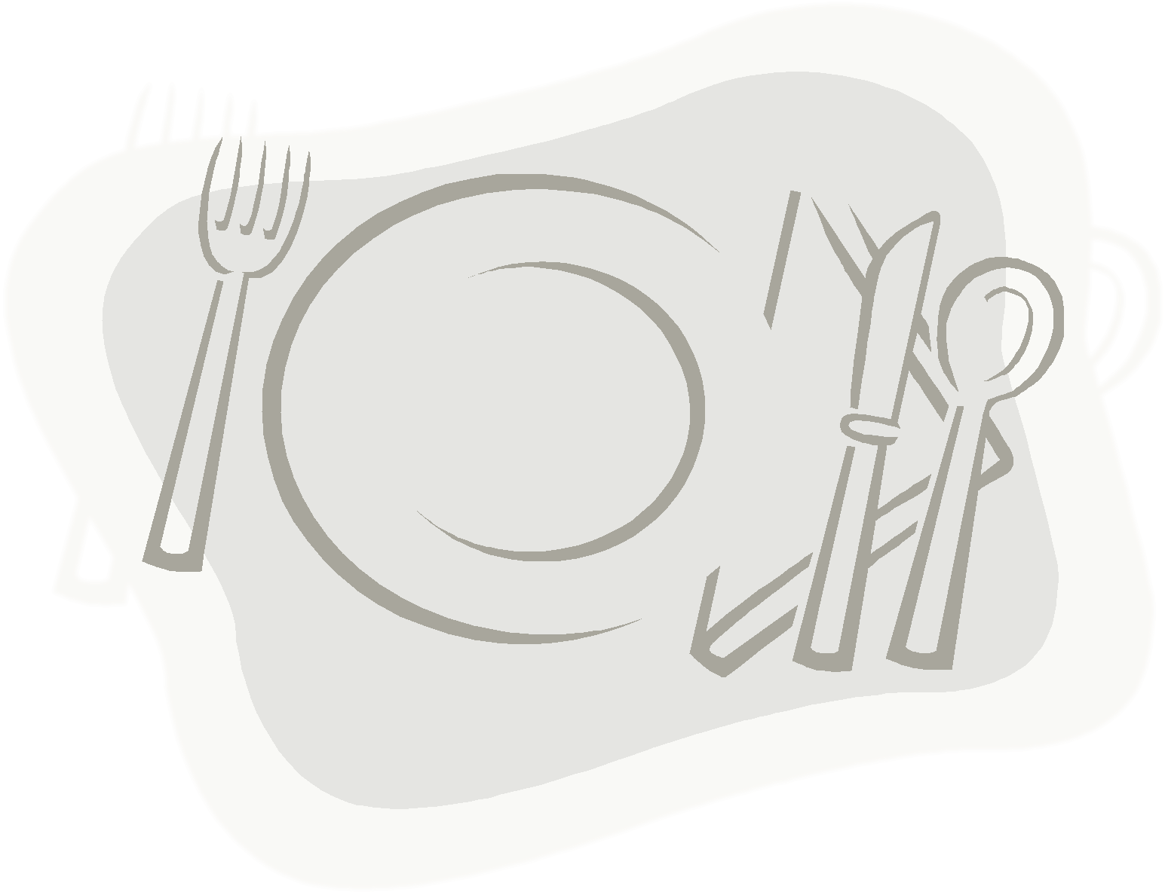  Jacket potato | 1 small
New potato | 2 egg sized
Mashed potato | 3 tablespoons
Tortellini | 4 pieces
Cous- cous | 3 tablespoons
Crisp bread | 2
Crackers | 3
Oat cakes | 2

Meat, fish and alternatives
These foods are good sources of protein. This is essential for new tissue formation, growth and repair of damaged tissue. Protein containing foods can also provide iron for healthy blood cells, B vitamins to prevent anaemia, zinc for the immune system and magnesium is essential for all cells.
A good protein intake is essential after surgery. This will help preserve your muscle mass yet burn fat. Long term it is recommended that you should always eat your protein first.
Red meat and chicken can often be difficult to tolerate. It is important to chew these foods well and you may find adding a low fat sauce or gravy can improve your toleration. Minced meat and fish tend to be easier for the stomach to digest and are therefore good alternatives.
Meat and meat products often contain high amounts of fat. It is advised that you aim for lean meats. Trim off visible fat, remove the skin from meat and grill your food rather than frying. Foods such as sausages, bacon and burgers should be avoided as they are still high in fat.
Fish is a healthy option to include at meal times. Oily fish such as salmon, fresh tuna, mackerel, kippers, trout and sardines contain omega-3 fatty acids. Omega-3 can help reduce your risk of heart disease. You should aim for at least 1 serving of oily fish per week. If you have had a heart attack it is recommended that you increase this to 2-3 times per week. Oily fish is moist and is generally tolerated well.
Other forms of protein such as eggs, beans, pulses can also increase your protein intake.
Meat, fish and Alternatives | Portion guide
Cooked chicken | ½ chicken breast
White fish | 125g
Minced beef | 3 tbsp
Salmon, sardines, makeral, herring, kipper, trout, tuna | 100g
Fish fingers | X2
Eggs | 1
Baked beans | 2 tablespoons
Lentils | 2 tablespoons
Tuna | 2 tbsp
Salmon | 1 small fillet
Chop | 1 small
Chickpeas, lentils | 2 tbsp
Soya or tofu | 100g
Quorn | 100g

Milk and Dairy

In the first few weeks after surgery it is important to have an adequate protein intake to help your wounds heal. Milk and dairy products are the perfect consistency (liquid and puree) and subsequently are good foods to include on a daily basis. Longer term these foods tend to be tolerated well and are good choices to increase your protein intake.

Full cream milk and cheese can be high in fat and to maximise your weight loss these should be avoided. Opt for reduced fat or low fat alternatives <5g total fat / 100g. Always check the food labels of yoghurts as they can be very misleading. Many products are labelled low fat but can be high in sugar. Products labelled low sugar can be high in fat (See food labels).
Milk and Dairy | Portion guide
Skimmed or Semi skimmed milk | 200ml
Low fat & Low sugar yoghurt | 1 pot
Low fat soft cheese
Cottage cheese | 2 tbsp
Soya milk | 200ml
Hard cheese | Small match box size
Cheese triangles | 2

Fruit and vegetables
Fruit and vegetables are an excellent source of fibre, vitamins and minerals. Fruit and vegetables also have a protective factor as they contain antioxidants that can protect against the development of some cancers and heart disease. Post surgery some patients can suffer from constipation. This is usually due to a poor fluid and fibre intake. If you do suffer from constipation then fruit and vegetables are a useful tool to alleviate this symptom.
Vegetables have little calorific value and are therefore a good food choice to help maximise weight loss. If you find that over time your portion size is increasing, then having additional vegetables is also a good way of feeling full whist avoiding a large increase in calories. Fruit and vegetables can be fresh, tinned or frozen. Some fruit has a high proportion of natural sugar and therefore large quantities are not recommended. For example; one litre of fruit juice contains approx 400 – 500kcals.
Following surgery raw fruit and vegetables and skins of fruit and vegetables can be more difficult to tolerate. It is recommended that you chew these foods well. This should help avoid discomfort and potential nausea and vomiting.
You should aim for 2 portions of vegetables with each meal. This could be 1 tablespoon of carrots and 1 tbsp of peas or 1 tbsp of sweet corn and 1 tomato. This can then be increased as tolerated.
Fruit & Vegetables | Portion guide
Salad | 100g
Broccoli | 2 florets
Cabbage | 1tbsp
Carrots | 1 tbsp
Onions | 1tbsp
Peas | 1 tbsp
Parsnip | X1
Mushrooms | 1 tbsp
Courgettes | 1 tbsp
Turnip | 1 tbsp
Peppers | 2 slices
Peas | 1 tbsp
Beetroot | 3 slices
Tomato | 1
Banana | 1
Pear | 1
Apple | 1
Avocado pear | 100g
Orange | 1
Grapes | 1 handful
Kiwi fruit | 1
Melon | 1 large slice
Dried apricots | 3
Strawberries | 1 handful
Raspberries | 1 handful
Plum | 1
Fruit salad | ½ small pack

Fats
Fats contain excessive calories and are a major contributing factor to weight gain. Fats also have a strong link with heart disease. Foods high in fat should be consumed only in moderation. Following bypass your body is unable to absorb high fat foods and therefore you will experience fatty stools if you eat high fat foods. It is highly recommended that you avoid.
There are differing types of fats in the diet. Some fats are better than others but ultimately you need to reduce the amount of total fat in the diet and aim for low fat foods.

Saturated fat
This is the worst type of fat (associated with high cholesterol). It is generally hard in appearance and is found in foods such as butter, lard, margarine, suet, full fat milk, full fat cheeses and fatty meats. It can also be found in meat products, pies, pastries, cakes and biscuits. To maximise weight loss it is recommended that you avoid saturated fats.

Monounsaturated fat
This is a better type of fat than unsaturated fat. It can help lower cholesterol but should only be consumed in small amounts. It is generally found in olive oils, rapeseed oils, spreads made from these oils, meat, hazelnuts, peanuts and seeds.

Polyunsaturated fat (Omega 6 and Omega 3)
This fat should be consumed in small amounts. Vegetable oils, soya oils, oily fish (such as salmon, mackerel, pilchards and sardines), nuts and seeds are a better type of fat, but ultimately to much will increase your calorie intake. Omega 3 oils are thought to be beneficial for heart health. You should aim for 1 portion of oily fish per week.
Foods such as butter, cream, full fat cheese, pastries, pies, crisps, chocolate and cakes are high fat and high calorie foods. Eating too many of these foods will increase your calorie intake and body weight.
Suitable alternatives include;
Fat | Portion guide
Margarine / low fat spread / reduced fat spread | 1 teaspoon
Oil | 1 teaspoon
Low fat salad cream | 2 teaspoons
Low fat mayonnaise | 2 teaspoons
Low fat salad dressing | 2 teaspoon
Low fat Cheese | Matchbox size
Reduced fat cheese | Matchbox size
Light or low fat sauces | 3 tbsp
Low fat Yoghurt | 1 pot

When looking at food labels check for the following;
Low Fat | Moderate Fat | High Fat
<3g / 100g | 10g-12g/100g | >20g / 100g

Sugars
Foods high in sugar should be consumed only in moderation. Chocolates, biscuits and fizzy drinks are convenient and easily accessible. They are comfort foods and probably the most difficult of all foods to consume in moderation. As these food items are very high in calories, a reduced consumption can be highly beneficial in assisting with weight loss. Following gastric bypass these foods will give you dumping syndrome and therefore you must avoid, or suffer the consequences.
Sugar | Suitable alternatives
Full sugar drinks | Diet / reduced sugar
Jam | Reduced sugar
Sugar | Artificial sweetener
Jelly | Low sugar jelly
Chocolate biscuits | Plain biscuits
Cake | Scone / malt loaf
Sugar coated breakfast cereals | Wholegrain cereals
Full sugar yoghurt | Low sugar yoghurt
Fromage frais | Low fat Fromage frais
Tinned fruit in syrup | Tinned fruit in juice

When looking at food labels check the following
Low Sugar | Moderate Sugar | High Sugar
<5g / 100g | 8g/100g | >12.5g / 100g

Fluids
The majority of individuals do not drink adequate amounts of fluids. This can lead to mild dehydration which can cause tiredness, loss of concentration, headaches and occasionally hunger pangs. Fruit juices and smoothies are a good source of vitamins and minerals but also contain a high amount of natural sugars therefore should be avoided. Following surgery it is more difficult to meet your hydration needs as you do not have a large amount of space in your stomach to hold fluids. It is recommended that you sip fluids throughout the day aiming for at least 8 – 10 cups a day. As previously discussed, avoid eating and drinking at the same time and avoid fizzy drinks.

Alcohol
Many people enjoy an alcoholic beverage and there is no reason why it should be completely avoided but alcohol should be consumed in moderation. It is recommended that women should have no more than 14 units of alcohol per week, and men to have no more than 21 units of alcohol per week. However, alcohol is high in calories and therefore reducing consumption can assist in weight loss. Mixers often contain a high amount of calories therefore aim for lower calorie versions. Fizzy
Following surgery you never have a large amount of food in your stomach to absorb alcohol. Subsequently alcohol will enter the blood stream much quicker and therefore be mindful of this when you drink.
Calorie content of alcoholic drinks | Kcals
Larger | 166kcals
Whiskey ( 25ml) | 56Kcals
Vodka | 56Kcals
Red wine | 170Kcals
White wine | 150kcals
White wine sweet | 200kcals
Champagne | 190kcals
Cider | 120kcals
Liqueurs | 70kcals
Coke | 135kcals
Lemonade | 120kcals

Understanding food labels and nutritional claims
Nutritional claims can be misleading. A product that reads low fat may be high in sugar to enhance flavour; this includes products labelled ‘diet’ products. The only true way to know if a product is what it claims to be is to check the nutritional composition label. The summary below gives clear guidelines on what you should be aiming for.
Nutrient | Low | Med | high
Total Fat | 3g | 10g | 20g
Saturated fat | 1.5g | 3g | 5g
Sugars | 5g | 8g | 12.5g
Salt | 0.3g | 0.9 | 1.5g

Consuming foods that are medium or high in fat, saturated fat or sugar will have a massive effect on your weight. To maximise your weight loss you should be aiming for low on a daily basis.
Nutritional claims can be very confusing and also misleading. With so many products claiming to be ‘healthy’ it is important to be able to understand what the different claims mean.
Many products can claim to be low in fat or low in sugar. Always check the label for the rest of the ingredients. A common mistake is that many low fat yoghurt’s may be low in fat but are high in sugar and therefore still contain a high amount of calories.
Claim | What does it mean?
Lite or light | The product must be at least 50% lower in at least one typical value (listed on the label or on the back of the pack), than standard product. For example if a packet of crisps is 50% lower in fat, 70% of that produce still contains fat. It is therefore a better alternative but still contains a high amount of fat and subsequent calories.
Low fat | The product contains no more than 3g of fat per 100g and is therefore a good choice.
No added sugar | The product has no sugar added to it, but this does not mean it is low in sugar
Fat Free | The product has no more than 0.5g fat and is therefore an excellent choice.
Reduced Fat | This product has 25% less fat than the product it is being compared to. It still contains a high amount of fat.
Low calorie | This product contains <40 calories per serving.
Sugar Free | The product is free from sugar. This is good choice. If you are not used to eating sugar free foods introduce slowly. Sugar free foods often contain artificial sweeteners that can have a laxative effect.

Snacks
If you snack on unhealthy foods such as biscuits, chocolates and crisps this will increase your body weight. Snacks do not have to be unhealthy. If you do feel hungry there are alternative healthy snacks that will help you keep control of your weight.
Healthy snack | Portion size
Banana | 1
Apple | 1
Pear | 1
Frozen grapes | 10
Carrots | n/a
Celery | n/a
Muller light | 1
Low fat rice pudding | 1
Dried cereal | 30g
Rivita with cottage cheese/low fat soft cheese | 2
Pea pods | n/a
Wholemeal toast | 1
Bagel with soft cheese | ½
Low fat low sugar fromage frais | 1
Bread sticks with cottage cheese | 4

Eating Out
Many people are anxious with regards to eating out after surgery. You may not be able to eat a large volume of food but you can choose options that better suit your smaller portion size. Starters are a good choice for a main meal. Many restaurants will prepare a small portion at request. If you feel full don’t feel obliged to eat all of your meal, there is nothing wrong with leaving food on your plate.
If there are certain foods that you find difficult to tolerate then it is not advisable that you retry when you are eating out. Choose a food that you usually tolerate well. Moist, softer foods are a good choice so that you do not have to worry about any side effects.

