VINTAGE VIC’S RECIPES FROM BYGONES DAYS
CORNED BEEF – Camping companion
In the 1940s Corned Beef was a popular part of the meat ration due to it’s availability. As it was already cooked it could be eaten cold or used in a variety of recipes. The fact it was tinned meant it could be stored easily and not wasted. As a camping dish it is easy to cook, safe to eat as it is tinned and very tasty.
This recipe was in The Quiver Economy Cookery Book:
BEEF (CORNED) CAKES
6oz corned beef
½ oz dripping
½ oz plain flour
1 onion
1 oz bread crumbs
1 egg
¼ pint stock or water
Pepper and salt

Finely chop onion, fry lightly.
Stir in the flour, use a sieve so it does not clump.
Add the stock or water and simmer gently for a few minutes. Continue to Stir.
Remove from stove.
Chop corned beef into squares. Mix in the corned beef.
Season to taste.
Add half the beaten egg.
Split up and shape the mixture into flat cakes.
Mix the bread crumbs with the remaining half of the beaten egg.
Dip cakes into the mix, then fry until golden brown.
Serve with vegetables and mashed potatoes.
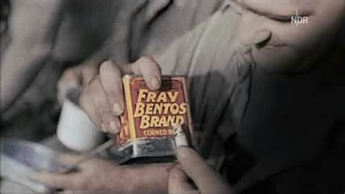
Provided by Vintage Vic, aka Victoria Shorland Eat To Live Nutritionist, www.eattolive.org.uk

